ECKINGTON WI – NEWSLETTER No.3

Wednesday June 3rd
Hello everyone and welcome to our virtual meeting. We hope you & your family are all well and keeping your mind, body and spirit safe. Hopefully it won’t be too long now before we can actually hold a meeting; restrictions are being slowly lifted and your Committee will be meeting soon to discuss how our first meeting might actually look, and what measures we may have to take to ensure a safe environment for all. Perhaps this is the one advantage of having a small committee – we can at least meet in our gardens!
NEWS FROM WFWI & NATIONAL:
Skittles: You should all have received the WFWI recent newsletter. Did you notice the 2019/2020 Skittles Competition has been curtailed? This is what WFWI had to say:
“Due to implications forced upon us by Coronavirus Guidelines, our skittles season came to a sudden end . Some teams had played all their matches, some had one game left to play and others had not really gotten started. Therefore an average of scores was calculated as per the rules, this identified a winner from each group: Group 1 Wychbury; Group 2 Mitton; Group 3 Sparkles; Group 4 Inkberrow; Group 5 Wickhamford; Group 6 Hanley Castle; Group 7 Hallow. The overall winner is Wychbury WI with a score of 56; Runner up is Wickhamford WI with a score of 55 and highest individual scorer was Pat Allcock from Himbleton WI with 63. Congratulations to all who played and to the winning WIs and members.”
Eckington WI had played 2 of their matches, and lost them, so we were never really in the running!
Resolutions: The following information has been released by NFWI:
“As the NFWI Annual Meeting was cancelled due to the COVID-19 pandemic, the two resolutions due to be discussed were not able to be debated or voted on by delegates. The NFWI Board of Trustees has decided that in these exceptional circumstances, the results of the shortlist selection process will be used as a proxy for the Annual Meeting vote. In the shortlisting selection stage, the two resolutions (stem cells and modern slavery) attracted a clear majority of selections from members (over 70%).
The NFWI Board felt that this was the most democratic means available to determine the outcome of this year’s resolution process taking into account time and resource constraints and the challenges of the current lockdown period. The Board also wanted to recognise the huge amounts of time and effort that members, WIs and federations put into the resolutions process this year. This means that the two resolutions have now been adopted by the WI, and members are free to campaign on these issues.”

OUR OWN NEWS:
Well what have our members been up to since our last newsletter? The phone buddy system is still going well and we remain connected with each other. New hobbies taken up by our members include:
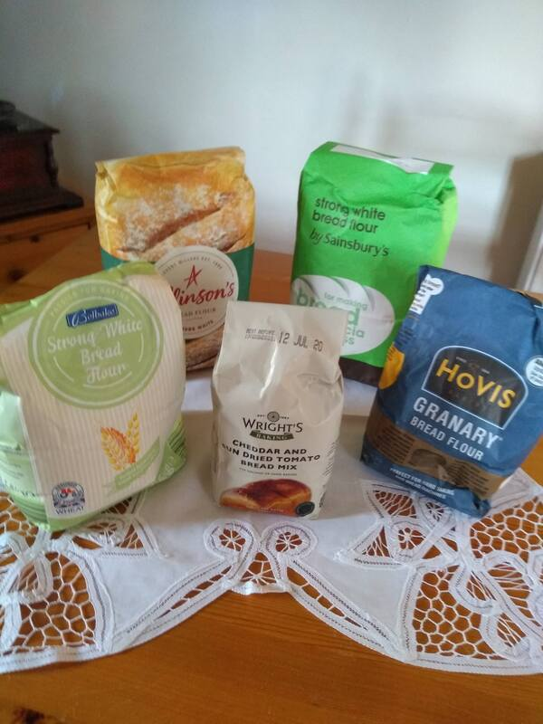
Yes, you’ve guessed it – flour arranging!
And one of our members has also been helping with the face masks for villagers:
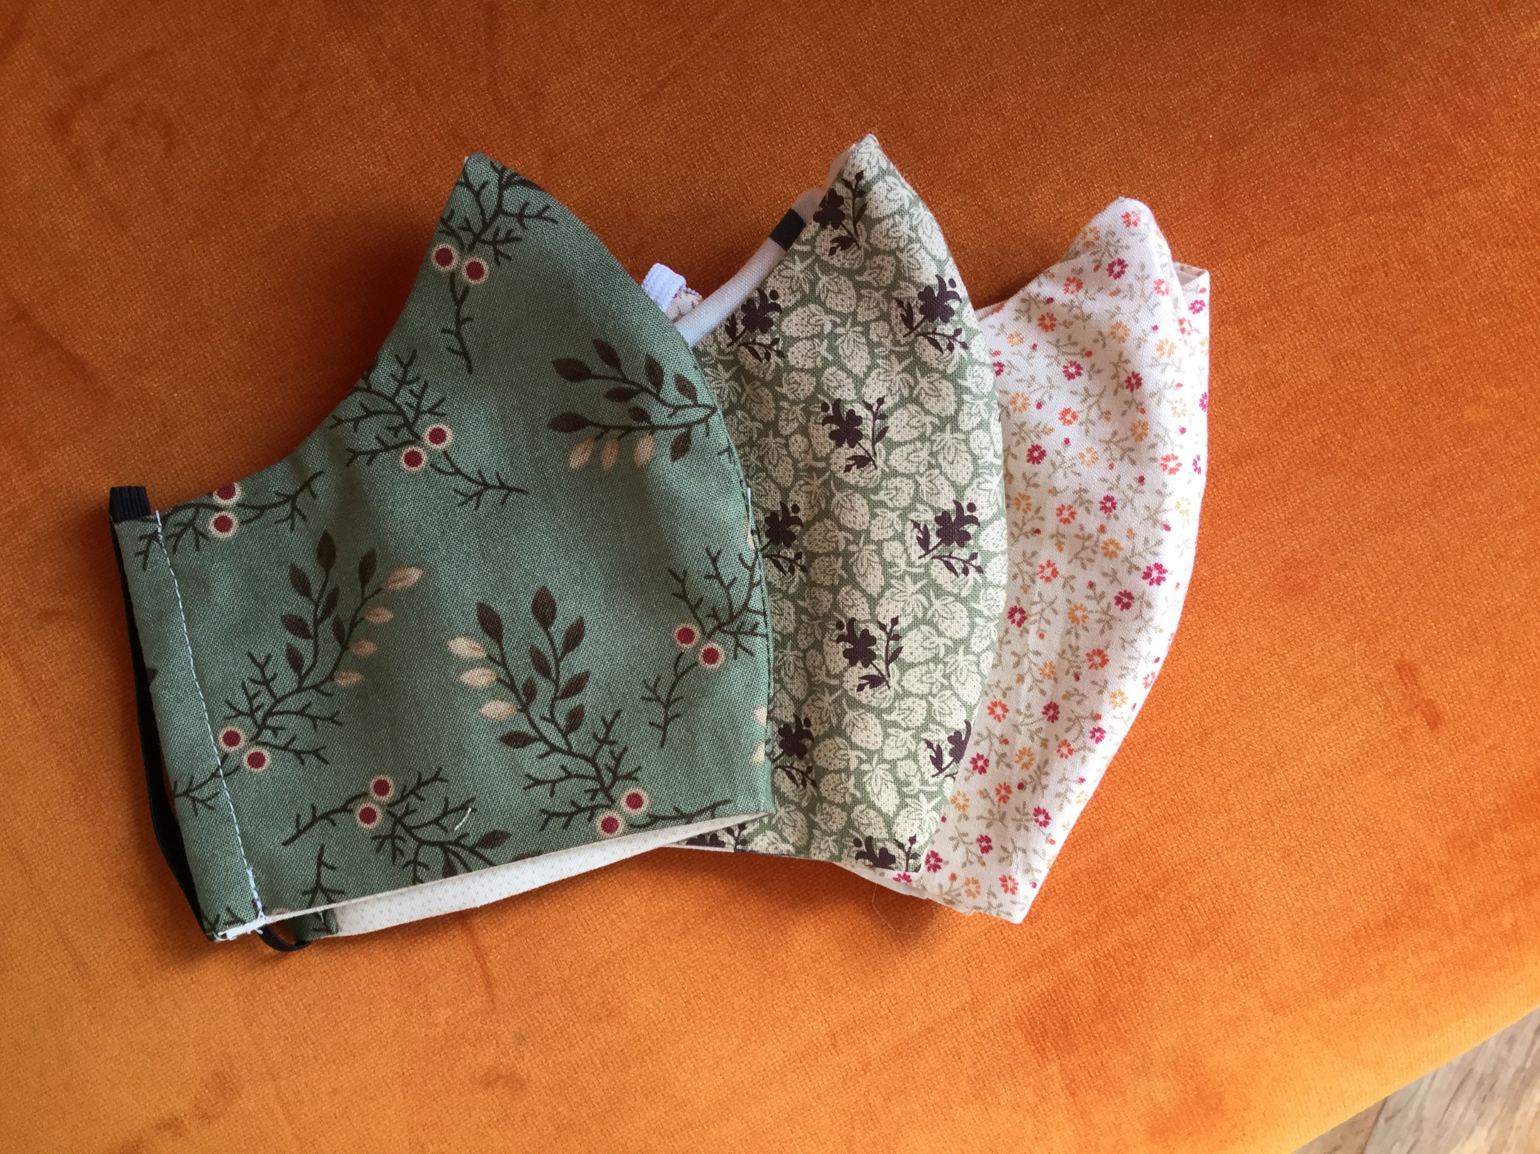

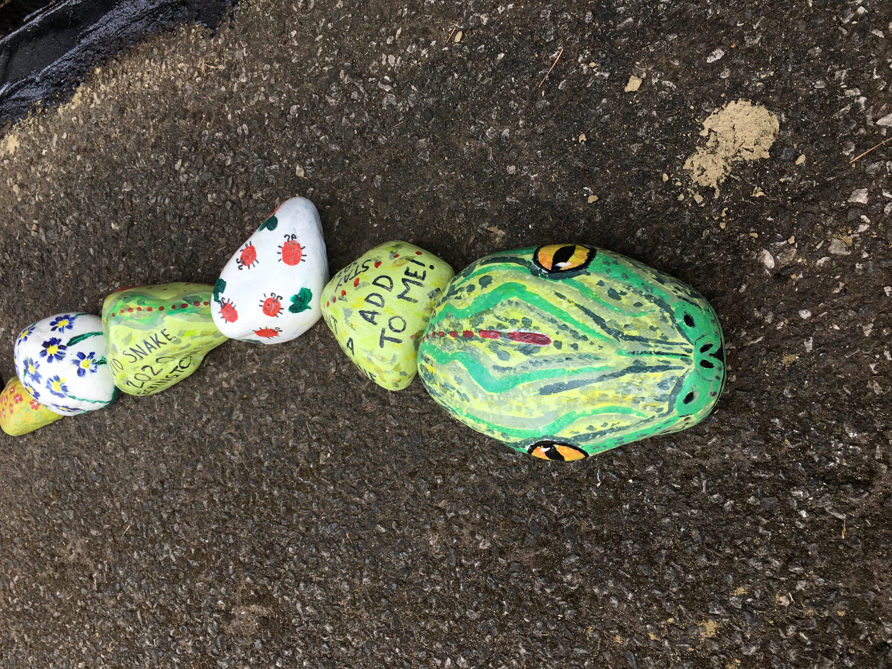

What not have a go at being creative as well. Paint a stone and add it to Ecki-snake – have you seen him at the Church?

FLOWER BOXES: whilst we are still operating under restrictions, the flower boxes are being looked after by Jo. We cannot operate our watering rota without difficulty so the boxes will just be kept tidy as best as possible until conditions change. Please also can you save any empty 2l or 4l milk containers to use for water carrying. Contact committee and we will arrange collection.
MEMBERS’ NEWS
- 3 birthdays this month so happy birthday wishes for Penny, Marilyn and Pam.
- Our best wishes also go to Marilyn who continues her recovery.
- Our thoughts are with Jeanne and Lindsay who are looking after their husbands who have not been well recently.

For our next newsletter or our next meeting (whichever comes first), do you have an anecedote, news, ideas or thoughts to share. If so, please let us know.
A reminder of an idea that was suggested in our last Newsletter is each member should note their best, their funniest and/or their worst memory of the lockdown. Write it down and we will look to ways of sharing these – perhaps a memory board at our first meeting?
Also why not make a name badge for our meeting? Any shape or design; we have members who have only been with us for a short time and it might help us all when we meet again.
Remember Sue Edwards is our well-wisher so please let her know if anyone is poorly or needs support.
And finally, we have the last quiz from Lindsay. Answers will be released next week. Better hope we meet in July as otherwise, we’ll have to find another quiz!
Until we meet again, be safe everyone.
Barbara
On behalf of your Committee x
PS – the June edition of the Village Newsletter is online at http://www.eckington.info/
PPS – fabric face masks are available from the Village Shop. £3.00 each or £5.00 for 2.

Email: eckingtonwi@gmail.com

Follow us on Facebook or visit our website at eckingtonwi.weebly.com

With Compliments from ECKINGTON WI

