BRAIN TEASER QUIZ : it’s a bit like CATCHPHRASE.
Here’s a hint. Look at number 3:
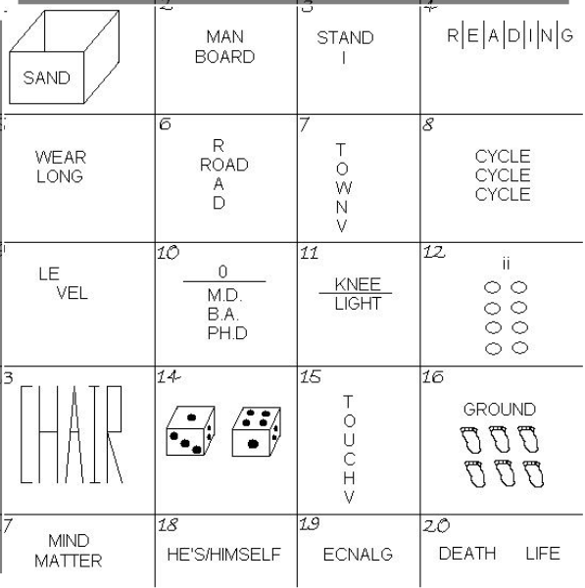
The word ‘stand’ is over the word ‘I’ or look at it another way and the word ‘I’ is under the word ‘stand’. So now you can say ‘I understand’ – hopefully!

ANSWERS: cover this bit up until you have written your answers down!
- Sandbox; 2. Man over board 3. I understand 4. Reading between the lines
5. long underwear 6. Crossroads 7. Downtown 8. Tri-cycle
9. Split level 10. zero degrees 11. Neon light 12. Circles beneath the eyes
13. High chair 14. to die for 15. Touchdown 16. 6 feet under ground
17. mind over matter 18. He’s beside himself. 19. Backwards glance
20. life after death.

HOW DID YOU DO?

