ECKINGTON WI – NEWSLETTER No.4

Wednesday July 1st
Hello everyone and welcome to our virtual meeting. We hope you & your family are all well and keeping your mind, body and spirit safe.
First we have a letter from our President:
Dear Friends,
Well this is the fourth month we have been unable to meet but hopefully there is light at the end of the tunnel and we will be able to resume our meetings in a month or two. We are awaiting information from national as to when and how future meetings will be conducted. Your committee are considering what format our first meeting may take and think it would be nice to have a social meeting, perhaps with a light supper, rather than have a formal speaker. If you have any ideas or preferences please email EWI or contact one of the committee.
Remember we are looking for new members to join the committee to help shape the direction of EWI in the future. If you would like an informal chat as to what being on the committee involves, please contact one of us for a chat.
While meetings have been cancelled, public affairs have continued with their campaigns and information about this year’s resolutions is on the MyWI website. The resolution timetable for 2021 is ticking away and so if the time in lockdown has made you think ‘something should be done about this or that’ and you think it would make a good WI campaign, then do look at putting a proposal together. The closing date for submissions is September 2020. WFWI have a resolution officer, Caroline Hall, who is happy to help any group who would like to submit a proposal, so do let me know your ideas.
I hope you have all received your County Newsletter this month and those of you not on email should have received a copy through the post.
Although we have had sad news about Arthur and Joan over the past couple of weeks, I hope this newsletter finds you and yours well and looking forward to being able to meet up with family and friends before too long. I know I have been delighted to have my daughter stay with me over the past week (we are both in single households so able to form a bubble) and just to make a few of you envious, as she is a hairdresser I’ve had a haircut. I hope many of you have now for July.
With very best wishes
Jenny
President

OUR OWN NEWS:
Well what have our members been up to since our last newsletter? Perhaps you have been too busy to let us know as the only thing we have to report is the committee did hold a socially distanced meeting in Sue’s garden just to catch up. It was good to see a few familiar faces. As far as we know, the phone buddy system is still going well and we remain connected with each other.
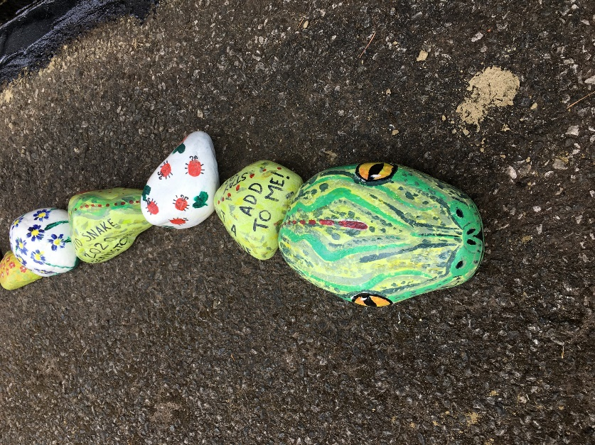

Did anyone add to Ecki-snake? Send us your photos please.

FLOWER BOXES: whilst we are still operating under restrictions, the flower boxes are being looked after by Jo. We cannot operate our watering rota without difficulty so the boxes will just be kept tidy as best as possible until conditions change. Please also can you save any empty 2l or 4l milk containers to use for water carrying. Contact committee and we will arrange collection.
MEMBERS’ NEWS
- 2 birthdays this month so happy birthday wishes for Kay & Judith.
- Our thoughts are with Jeanne after the recent death of Arthur and are also with the family of Joan Green who died suddenly last week.
PLASTIC FREE JULY
July is designated plastic free month. At the end of this Newsletter is a 31 Day Challenge – can you do it? Try at least one or two of the ideas. During this current pandemic, the use of plastic is likely to increase: more people will be using disposable gloves & masks, shopping will be delivered in plastic bags whether you like it or not etc. So it is really important that we try to limit the impact of plastic waste wherever we can. You can buy bio-degradable gloves or use cotton ones that you can wash; cotton washable masks are available at our village shop. There is little you can do to stop your shopping being delivered in plastic bags but don’t throw them away. There are ways of re-purposing them; if you are on Eckington Village Facebook page, you will see there were a number of suggestions on this.

For our next newsletter or our next meeting (whichever comes first), do you have an anecedote, news, ideas or thoughts to share. If so, please let us know.
A reminder of an idea that was suggested in our last Newsletter is each member should note their best, their funniest and/or their worst memory of the lockdown. Write it down and we will look to ways of sharing these – perhaps a memory board at our first meeting?
Also why not make a name badge for our meeting? Any shape or design; we have members who have only been with us for a short time and it might help us all when we meet again.
Remember Sue Edwards is our well-wisher so please let her know if anyone is poorly or needs support.
And finally, a quiz! It is a picture quiz of great British engineering icons can you name them; answers next week.
Until we meet again, be safe everyone.
Barbara
On behalf of your Committee x
PS – the July edition of the Village Newsletter is online at http://www.eckington.info/

Email: eckingtonwi@gmail.com

Follow us on Facebook or visit our website at eckingtonwi.weebly.com

With Compliments from ECKINGTON WI

